1. DON’T FOLLOW THE OFFICIAL WEBSITE’S GUIDE ,

If you have pushed your project repo to BB before.

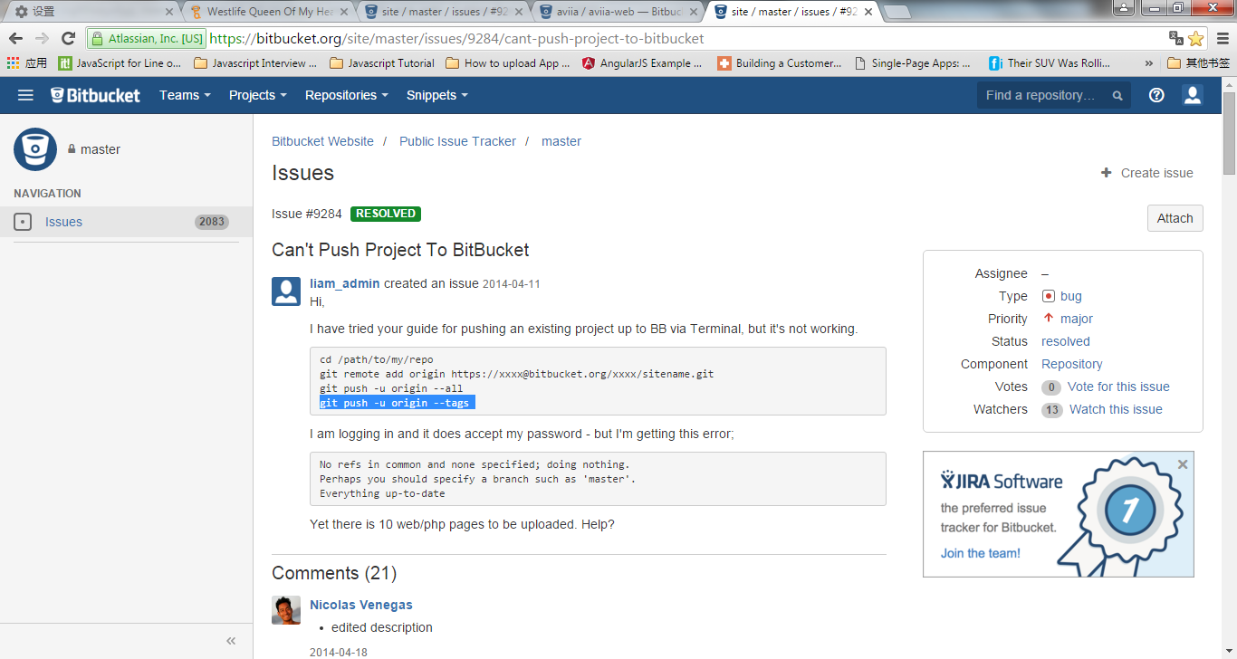

1. Following the below:

OPEN GIT COMMAND WINDOW FIRST!!

1. $Cd (your path)
2. $git add .

* Not $ git init no more! Since your local repo have .git file already

1. $git commit –m ‘my 2nd commit to BB”
2. $git remote add origin https//\*\*\*\*\*\*\*\*\*\*\*\*\*/aviia-web.git
3. $git push –u origin –all

* You will be asked : passwork for your BB a/c

1. $git push –u origin –tages

* Againk, You will be asked : passwork for your BB a/c



